Concentrated Prayer for Wandering Minds

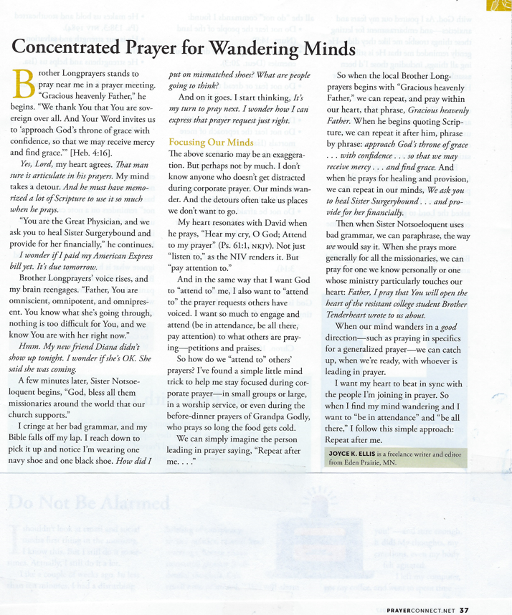by Joyce K. Ellis

© Joyce K. Ellis

Originally published in *Prayer Connect*,

April–June 2017, [www.prayerconnect.net](http://www.prayerconnect.net)