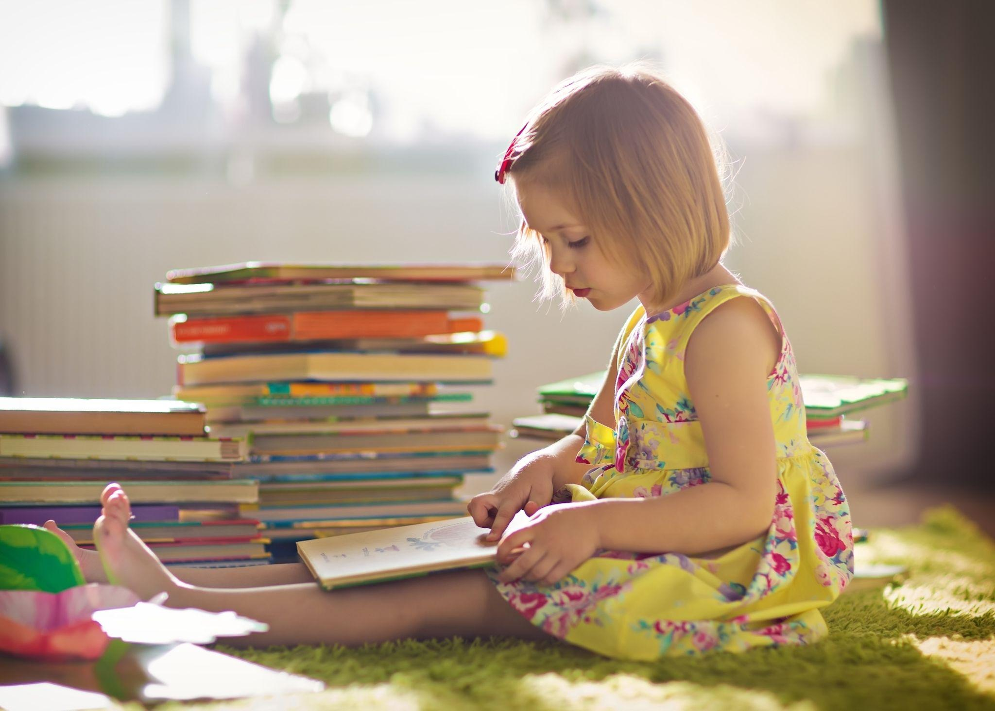**Picture Yourself Writing for Kids?**

**by Joyce K. Ellis**

When people find out I’m a children’s author, they often say, “I have a great picture book idea. Got a few minutes? I’d love to pick your brain.” Ew! Sounds painful.

And trying to cover writing for kids in a single blog post is like trying to cover a bull elephant with a baby blanket. So let’s focus on picture books. Many assume it’s the easiest kind of writing. Spoiler alert: It’s *not.* But whether books address spiritual topics or not, our world needs children’s writers who write from a Christian worldview. Consider the “calling” of Psalm 22:31. “Proclaim his righteousness, declaring to a people *yet unborn*: He has done it!” (NIV, emphasis added). Any material we’re writing today may reach tomorrow’s little ones “yet unborn.”

**Reading preparation**

Where do you start? The best advice I ever received is this: If you want to *write* picture books, first *read* 100 picture books. Yes, 100! At least.

Make a new best friend: your local children’s librarian. Then look on www.Goodreads.com, [Amazon.com](https://amazon.com/), [bn.com](https://bn.com/), [thriftbooks.com](https://thriftbooks.com/), and [Christianbook.com](https://christianbook.com/). Ask friends for recommendations. Scour thrift stores and garage sales. Search for Internet lists, such as [**https://tinyurl.com/GoodreadsPicBks**](https://tinyurl.com/GoodreadsPicBks). Build the biggest picture book library you can afford. *Study* it all.

A few more tips . . .

* From general-market publishers analyze a variety of seasoned classics, e.g., *Curious George*(Rey) and *Alexander and the Terrible, Horrible, No-Good Very Bad Day*(Viorst).
* Include more recent favorites, e.g., *Love You Forever* (Munsch) and *If You Give a Mouse a Cookie* (Numeroff).
* Enjoy wacky bestsellers, e.g., *Click, Clack, Moo*(Cronin) and*7 Ate 9*(Lazar)—whatever your library can’t keep on the shelves.
* From Christian publishers, explore outstanding examples, e.g., *I Want Your Smile, Crocodile*(Fretz) and [***I Love You to the Stars: When Grandma Forgets, Love Remembers***](https://www.amazon.com/Love-You-Stars-Grandma-Remembers/dp/0825446473/ref=sr_1_6?crid=2MABGPXY0JH18&keywords=crystal+bowman+picture+books+grandma&qid=1698703476&s=books&sprefix=crystal+bowman+picture+books+grandma%2Cstripbooks%2C94&sr=1-6)(Bowman).

As you read, create a spreadsheet that includes at least title, author, illustrator, publisher, year released, and number of pages. You’ll learn a lot. For example, these days, most publishers prefer 32 pages (some of which can’t contain your story), a total of 1,000 words—even better, 500 words. Then develop analytical skills by writing reviews on Goodreads.

You don’t have to find an illustrator, by the way. Editors want to see the text only, not illustrations. They have connections and know artwork well. *They* choose the illustrator.

Reading preparation also includes learning from other writers. Join SCBWI (Society of Children’s Book Writers and Illustrators). Their handbook, simply called *The Book,*answers more questions than you’d think to ask. Local SCBWI groups often provide instruction and critiques.

 Learn from websites of successful picture book writers, such as Mem Fox, author of amazing books such as *Ten Little Fingers and Ten Little Toes* ([**www.memfox.com**](http://www.memfox.com/)).  Subscribe to their blogs. One of my favorites is Tara Lazar’s *Writing for Kids (While Raising Them*)—[**www.taralazar.com**](http://www.taralazar.com/).

**Writing preparation**

Become a copyist (not a plagiarist, of course). My younger daughter never knew a time when I wasn’t a writer. In early elementary school, she copied some of her favorite chapter books into a notebook, word for word, saying, “I’m doing my writing.” Decades later, she has strong writing skills, thanks to her work as a “copyist.”

Copying various picture book texts (always noting titles and authors) helps us absorb good sentence structure for different age groups, learn pagination, and get a feel for salability.

As you develop your own picture book idea, shape the text into single-page and two-page “spreads” according to the standard template: [**https://tinyurl.com/picturebooktemplate**](https://tinyurl.com/picturebooktemplate). Does the text on right-hand pages entice the child to know what comes next, e.g., *The Monster at the End of This Book*(Stone)?



**Know your dual audience**

The best picture books delight adult buyers reading to children as much as the children themselves. Case in point: Tara Lazar’s hard-boiled-detective spoof, *7 Ate 9.*From topic to content to word choice—everything—“know your audience” is still cardinal writing advice. What are some popular TV shows, video games, and apps that picture-book-age kids engage with?

Have you avoided vocabulary that kids can’t figure out from context? Can you include plays on words or objects from their parents/grandparents’ past to add extra humor to the text?

When all is said and done, most “let me pick your brain” advice seekers never follow through on that first bit of counsel: First, read 100 picture books.

Picture yourself as the exception. Then “let this be written for a future generation, that a people not yet created may praise the Lord” (Psalm 102:18 NIV).

© Joyce K. Ellis